**Exercises week 2**

**Task 1:**

**Try to draw a causal diagram for each of the scenarios described in the left column. Assess whether or not there is an open back-door paths.**

|  |  |  |
| --- | --- | --- |
| **Scenario** | **Causal diagrams** | **Is there an open back-door path? If so, why? What would you do to close the open back-door paths?** |
| Researchers found an association between hip replacement and poor hearing in an unadjusted analysis. Might they have missed an important third variable? Draw a DAG to explain what might be happening. |  | Yes, there is an open back-door path since we did not condition on the common source age. The researcher should have conditioned on age by, for example, adjusting their statistical analyses. |
| Researchers investigated the relationship between smoking and colon cancer. They adjusted the analysis for sex. |  | There is no open back-door path since the researchers conditioned on the common source sex. |
| Stroke and cancer both increase the probability that participants get admitted to hospital.  Two researcher teams investigated whether stroke increases the risk for cancer.  Researcher team 1 selected their participants among hospitalized stroke patients and found an increased risk.  Researcher team 2 selected their participants among hospitalized and non-hospitalized stroke patients. They did not find an increased risk.  Draw two DAGs and explain why the researcher teams might have had different results? | Researcher team 1:    Researcher team 2: | Both diseases increase the risk for hospitalization (common effect). The first researcher team restricted to hospitalized participants, therefore conditioned on common effect and thereby opened backdoor-path. Researcher team 2 did not condition on the common effect, therefore, the backdoor-path is closed. |
| A researcher team is interested in the association between a genetic variant and smoking. Both smoking and the genetic variant are associated with lung cancer. Lung cancer is associated with chemotherapy.  Draw a causal diagram showing the situation in which researchers did not condition on any of the variables. Is there an open backdoor-path? |  | There is no open backdoor-path because the researcher neither conditioned on lung cancer nor on chemotherapy. |
| A researcher team is interested in the association between a genetic variant and smoking. Both smoking and the genetic variant are associated with lung cancer. Lung cancer is associated with chemotherapy.  Draw a causal diagram showing the situation in which researchers restricted the sample to participants who are not on chemotherapy. Is there an open backdoor-path? |  | There is no open backdoor-path because the researcher conditioned on a descendent of a collider (chemotherapy) by restricted the sample to subjects that are not on chemotherapy. |

**Task 2:**

**Read the heading of the newspaper article. Do you think that taking naps is causally related to heart disease? Explain your answer by drawing a causal diagram of the situation. Do not include more than four variables in the diagram.**

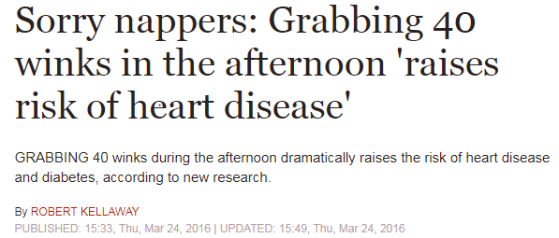

Source: <https://www.express.co.uk/life-style/health/655338/afternoon-nap-raises-risk-heart-disease>

I don’t believe that taking naps is causally related with heart disease. I believe that people who are taking naps in the afternoon are very different from people who do not take naps in the afternoon. The DAG could look like this:

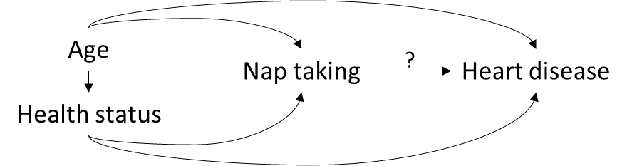

In this causal diagram nap taking and heart disease have two common sources (age, and health status). Since there was no conditioning on any of the variables, we cannot interpret our estimates of nap taking on risk of heart disease causally. Since no other variables are included in the DAG, we assume that these three variables are sufficient to show the causal network of the relationship between adult socioeconomic status and dementia.

Your DAG might look different. That’s okay. You just need to be able to explain what your DAG shows.

**Task 3:**

**We are interested in the causal relationship between adult socioeconomic status and subsequent dementia. Draw a causal diagram taking childhood IQ into account. Indicate what assumptions you have made.**

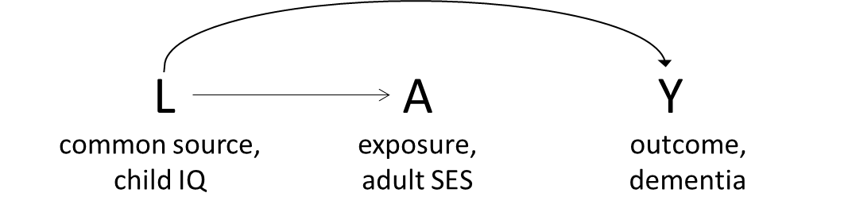

Childhood IQ was assumed to be a common source of both adult socioeconomic status and dementia. Since no other variables are included in the DAG, we assume that these three variables are sufficient to show the causal network of the relationship between adult socioeconomic status and dementia. The DAG was drawn under the null hypothesis of no causal relationship between adult socioeconomic status and dementia, given childhood IQ.